**21st December 2015**

**Yokohama Tire Manufacturing Virginia, LLC Celebrates Major Milestones**

The Salem plant commemorates its 25th anniversary and production of its 80 millionth tyre

SANTA ANA, CA (Dec. 21, 2015) – Two major milestones recently occurred at Yokohama Tire Manufacturing Virginia, LLC (YTMV): the Salem, Virginia facility celebrated its 25th anniversary and produced its 80 millionth tyre.

“These are two very significant achievements for YOKOHAMA, particularly in the U.S.,” said Tetsuro (Tex) Murakami, YTMV president. “The plant helped establish our brand by providing a strategic manufacturing facility in the United States to serve both the OEM and replacement markets. Twenty five years later, the 80th million tyre – an AVID Ascend® with YOKOHAMA’s signature technology, orange oil – rolled off the line. The accomplishments are a testament to the dedication and hard work of our employees.”

YTMV has also been at the forefront of YOKOHAMA’s environmental achievements in the U.S. This year, the plant became a zero landfill operation and received the 2015 Environmental Warrior Award from the Virginia Water Environment Association (VWEA). The award was bestowed to YTMV as part of VWEA’s 2015 Industrial Waste and Pre-treatment Environmental Excellence Awards Program.

YTMV has additionally been highly active in its parent company, The Yokohama Rubber Co., Ltd.’s, ongoing global initiative, Forever Forest. The initiative aims to plant approximately 500,000 trees around YOKOHAMA’s facilities worldwide by 2017. In 2009, YTMV became the first YOKOHAMA plant to hold a tree-planting ceremony outside of Asia. Since then, nearly 11,000 trees have been planted at the Salem facility.

The plant has been ISO 14001 Environmental Management System-certified since 2007.

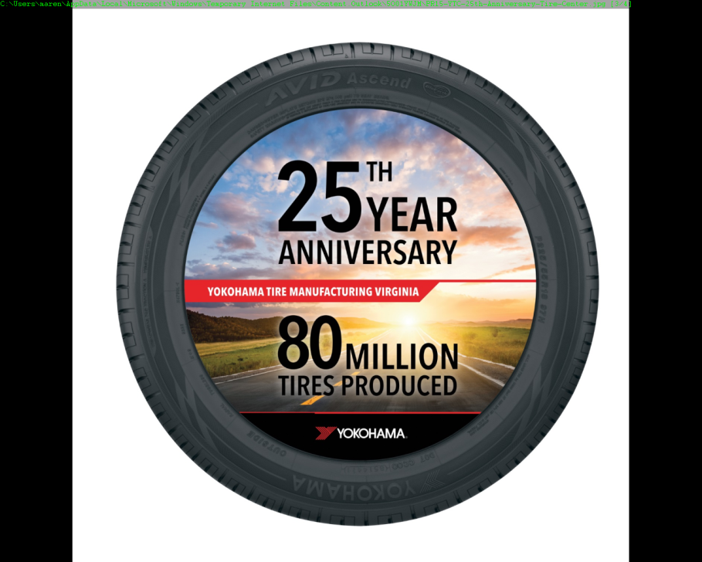

PR15-YTC-25th-Anniversary-Tyre-Center